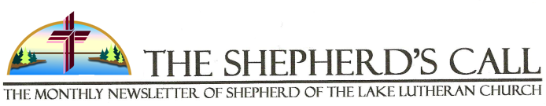
September 2017 Vol. 11 No. 09

“Happy Anniversary”

Someone other than my wife reminded me of the importance of anniversaries: a church member came through the greeting line after service and wished me and my wife “a happy anniversary.” My response to that comment was “thank you,” but also added that the “big one” will be happening next August. Upon hearing that, a visiting couple added that they too are celebrating their 40th next year. 40 is one of those big and well known numbers found in the Bible as well as in our personal lives which marks significant events in the life of God’s people.
As Lutheran Christians we are preparing for a big anniversary in the life of the church, and even beyond the church – the 500th anniversary of the Lutheran Reformation. In the Fall of 1517, Martin Luther nailed the 95 theses to the church door in Wittenberg, Germany.
This event impacted the church and the world in a profound way such that authority, personal assurance , vocation, education and family life would never be the same…and all of the afore-mentioned would be transformed by the biblical, gospel message that “Christ Alone” is the difference maker.
Other Christian denominations owe their beginning and development to Luther’s work of reforming the church. This is an anniversary that continues to shape our identity in a world that continues to struggle and lose its identity and purpose. An anniversary, whether it be marriage, church or other, ties us to real history and real people in a meaningful way. In a greater way, an anniversary in time unites us with the eternal, and gives us ultimate meaning.
An anniversary means that it is incumbent upon us as beneficiaries to recognize our dependence on the critical work and sacrifice of those before us; but that also we have a privileged role and obligation in shaping the path for future generations to share in the blessings of that event.
As we approach October in this year, 2017, let us join in the anniversary celebration that
continues to shape us as God’s redeemed people. May you be renewed and refreshed in your appreciation of God’s work and blessing in your life and the lives of others – especially in this anniversary year!

Happy Anniversary,

Pastor Thomas Petersen

PRAYER REQUESTS: If you have someone or something that you would like Pastor Petersen to include in either his personal prayers or in our public Prayer of the Church on Sunday morning, please fill out a prayer request card, located on the guest book stand, and place it in his box or contact him at the Church Office. It is important that all of our members receive pastoral care when it is needed, especially during times of sickness or other difficulty. If you know of an individual, even if it is a non-member, who would appreciate and benefit from a pastoral visit, please contact the church office or Pastor Petersen.
PASTORAL OFFICE HOURS: Pastor Petersen will plan to be in the church office Monday through Thursday from 8:30 a.m. to 12:30 p.m. There are exceptions to this schedule as there will be a circuit pastors meeting on the first Monday of each month, a Wednesday morning chapel at the Aitkin nursing homes every six weeks, and other meetings or activities within the church during those morning hours. If you wish to meet with the pastor for a specific and personal reason, you can always make an appointment for most any time during the week – morning or afternoon – and if need be, in the evening. He would prefer that you call his cell phone at 608-334-5718 or email him at sotlpastortom@gmail.com to ensure prompt response to your requests or need. The Church secretary is in the office on Tuesday’s and Thursday’s from 7:00 a.m. to 1:30 p.m. if you need her for anything.

ELDER OF THE MONTH
Gaylord Ryg
320-692-4789

USHERS FOR THE MONTH
Larry Collison
Doug Feltmann

ALTAR GUILD:
Marge Berndt

FELLOWSHIP SERVERS
03rd
10th Randy & Faye Feltmann
17th Darwin & Shari Beck
24th

Many thanks to all our volunteers! If you are able to help, please see the bulletin board for opportunities. Thank you!

BIRTHDAYS IN SEPTEMBER
01st Sarah O’Neil
05th Marilyn Reinking
06th Dwight Bruckhoff
07th Steve Lawrence
08th Kylie Hoese
Marie Nelson
12th Lucy Knowlen
18th Anna Leerssen
19th Dennis Anderson
20th Bill Uhlig
21st Elaine Drahosh
24th Doug Feltmann
26th Jo Petersen
Geri Posner

ANNIVERSARIES IN SEPTEMBER
04th Terry & Vicky Thurmer
11th Bill & Linda Alleman
24th Dwight & Robin Bruckhoff
30th TJ & Tiffany Gustin

YOUTH BIRTHDAYS IN SEPTEMBER
20th Luke Rusnak

CHRISTIAN EDUCATION
Sunday Morning Study: at 8:30a.m.
Studying about the Apostles
Wednesday Morning Bible Study: at 9:30 a.m.
Finishing up with, Luther’s “Large Catechism.”
We will soon be starting up
a LifeLight Bible study “End Times”.

QUILTS—QUILTS—QUILTS: “Tied in Faith, Sent in Hope, Wrapped in love”: The Ladies are busy making quilts again and welcome all who would like to help in any way with putting together quilts for Lutheran World Relief. The Ladies are getting together on Tuesday mornings at 9:00 a.m. They welcome all donations of old sheets, old thin blankets and odd materials that can be used to make quilts. They are also looking for more volunteers to help in making these quilts.

CHURCH LAWN MOWING: The Trustees are looking for help with mowing the lawn at the church again this year. If you are able to help please check the sign-up sheet on the bulletin board. If you have any questions please contact Larry Collison.

SUNDAY SCHOOL RALLY DAY: September 10, 2017 will be our Sunday School Rally Day! We are looking forward to seeing all the children once again!

ANNUAL LWML FALL BAZAAR: It is that time of year again when we need to start thinking and preparing items for the Annual Bazaar. This year the Bazaar will be on Saturday, October 21st and will run from 9:00 a.m. to 2:00 p.m. We will be selling baked goods, craft items, jams and jellies, and of course Lefse! We will be serving a luncheon again along with pies. Please watch for updates in the upcoming bulletins and the October Newsletter.

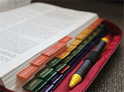
BRATS SALE: The policies for Thrivent have changed so the Brat Sale will be for Shepherd of the Lake (to be used as the Church Council determines) on Friday, September 1st and Saturday September 2nd from 9:00 a.m. to 5:00 p.m. We are looking for people to help with this event. You will find a sign-up sheet on the bulletin board. All help will be greatly appreciated.

WORLD RELIEF SCHOOL KITS: We are planning to gather school kits this fall for Lutheran World Relief. The plan is to begin the in-gathering on August 6, 2017 and end it on September 3rd.
Education is important for every community, especially where poverty or disaster has limited the options for young people to reach their potential. School kits contain essential supplies to help children—and in some cases adults—continue learning despite the hardships they face. That learning leads to a better life for them, their families and their communities.
School Kits Items:
- Four 70 sheet notebooks of wide or college-ruled paper; no loose-leaf paper
- One 30-centimeter ruler, or a ruler with centimeters on one side and inches on the other.
- One pencil sharpener
- One pair blunt scissors (safety scissors with embedded steel blades work well)
- Five unsharpened #2 pencils with erasers; secure together with a rubber band
- Five black or blue ballpoint pens (no gel ink); secure together with a rubber band
- One box of 16 or 24 crayons
- One 2 ½” eraser
- One sturdy drawstring backpack-style cloth bag, approximately 14” x 17” with shoulder straps (no standard backpacks)
Please do not add other items or leave out any of the items listed. All items should be new and in good condition. Remove any excess packaging, pack all items in bag and close. Do not enclose the Kit or any of its contents in plastic bags.

WEDNESDAY MORNING BIBLE STUDY: This class will be finishing up with Luther’s Large Catechism soon and then they will begin with LifeLight study on End Times. The class meets at 9:30 a.m. All are welcome to come.

NEW MEMBER: We welcome Lee & Linda Lennander to Shepherd of the Lake. Lee & Linda transferred their membership to Shepherd of the Lake. Welcome, Lee & Linda!

RECYCLING ALUMINUM CANS: We are accepting all donations of empty and recyclable aluminum cans to support our Sunday school program. Please bag the cans and bring the bags to the trailer beside the garage. Thanks!

BIRTH ANNOUNCEMENTS:
Congratulations to James & Anna Reem and family, and Grandparents John & Mary Kinzel, on the birth of Jayme Kay Reem, born July 27, 2017.
Congratulations to Zach & Lynn Lund and family and Grandparents, Steve & Beth Lawrence on the birth of Sawyer Lund, born August 3, 2017.

MISSION PROJECT UPDATES: Lakes Area Pregnancy Support Center: The Baby Bottle Campaign results: The 2017 baby bottle campaign was our biggest ever! Shepherd of the Lake raised $117.60. Overall, the campaign has brought in $34,536.20 to date (July 31st). Bottles were still coming in so these numbers will increase. LAPS wishes to thank everyone for helping to make this campaign such a success!
Concordia Gospel Outreach: Our Vacation Bible School collected money for Concordia Gospel Outreach and we were able to donate $480.79 to this worthy cause. This gift will help to put the Gospel in the hands of more people who have not yet heard the Good News
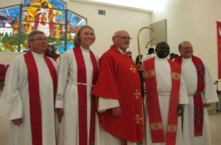

Decades later, a former refugee remembers his quilt
By all accounts, Pastor Del Akech Del has lived an extraordinary life so far. As a member of the refugee group that came to be known as the Lost Boys of Sudan, he lost family members, fled from civil war, and sought refuge in two different countries before coming to the United States as a refugee in 2001.
“I fled the country with other Lost Boys because of the war in South Sudan that broke out in 1983 between Muslim Arabs in the North and Christians in South Sudan,” explains Del, who now serves as interim pastor at St. Christopher Lutheran Church in Lykens, PA. “There were many life-threatening challenges on the way to Ethiopia, but I made it safely even though some relatives and friends died in the desert.”
Listening to his story, and all that he’s gone through, you might be surprised to know that one seemingly small act of kindness still stands out in his mind to this day – while in a refugee camp in Ethiopia, Del Akech Del received the gift of a quilt.
When Del arrived in Ethiopia in 1987, he says and the other Lost Boys lacked many of the most basic necessities of life. “I spent about six months with other Lost Boys of Sudan without food or clothes,” he says. “But most importantly, there were no blankets to keep me warm when it was cool at night.”
A few months later, Del recalls, the United Nations High Commissioner for Refugees delivered supplies. And with those supplies came very special gifts. “You may be surprised when I tell you this, but the quilts you spend hours putting together saved millions of lives in refugee camps around the globe.”

Pastor Del saw those quilts used in a variety of ways. “Women used them as skirts because there were no sewing machines at that time,” he says. Some people used them as blankets for their beds and even, Del says, as protection against malaria-bearing mosquitoes. “That didn’t work well, though, because it was hard to breathe under the quilt.”
We already know that a well-padded quilt is useful to refugees who very often face harsh weather conditions. Pastor Del also recalls that the thickness of the quilt determined how it was used. “If a quilt was double, two people would share it. If it was triple, three would share it,” says Del, meaning that if a quilt had double or triple batting, it was shared between more than one person.
In 2001, Del came to the United States as a refugee, but long before that he began worshipping God and sharing the story of Jesus with others. Once in the United States, he led worship for fellow Sudanese refugees and eventually connected with the Evangelical Lutheran Church in America (ELCA) through which he became an ordained pastor, completed seminary and eventually got his Master of Divinity degree. He now serves several communities, including the Sudanese refugee community of the Lancaster area.
Pastor Del uses his life story as a testimony to God’s grace, and fondly recalls that quilt, given to him so long ago, as one of many blessings he’s received along the way. “God is always present in our lives regardless of life struggles and setbacks. I always share my story and remind my church members about my hard-earned life experiences. I believe God knows everything we lack and in God’s time His response to our prayers is always right.”

FARMERS MARKET: Have an abundance of produce? Share it with your Shepherd of the Lake family. No garden? Pick up produce at the Farmers Market table in the Fellowship Hall. Any cash donations will go to help ship our Lutheran World Relief quilts. Excess produce each Sunday will be taken to the Garrison Food Shelf.

LOUISIANA CORN BREAD
From the kitchen of: Bernice Ranallo

1c. Margarine
½ c. shredded Cheddar Cheese
1 c. Sugar
1 c. Flour
4 Eggs
1 c. Yellow Cornmeal
1 (4 oz.) can chopped Green Chilies
1 (15 oz.) can Creamed Corn
4 tsp. Baking Powder
½ tsp. Salt

Cream butter and sugar; add eggs, one at a time. Mix well. Add chilies, corn, and cheese; mix well. Mix flour, cornmeal, baking powder, and salt. Add to wet ingredients; blend well. Pour into greased and floured 9 X 13 inch pan. Place in preheated 350° oven and bake 15 minutes, then reduce heat to 300°. Bake 1 hour

Shepherd of the Lake Lutheran Church
September 2017
Sunday | Monday | Tuesday | Wednesday | Thursday | Friday | Saturday
 |  |  |  |  | 1  9AM-5PM  Brat’s Sale  By SOTL | 2  9AM-5PM  Brat’s Sale  By SOTL
3  8:30 a.m.-Bible Study  10AM-Divine Service w/LS  11AM-Fellowship Hr | 4 Labor Day  Office  Closed | 5  9AM-Quilting Group | 6  9:30 a.m.-Bible Study | 7 | 8 | 9
10 Grandparents day  8:30 a.m.-Bible Study & Sunday School Rally Day  10AM-Divine Service w/LS  11AM-Fellowship Hr  District Fall | 11  Pastor’s  Conference | 12  9AM-Quilting Group  1PM-LWML Meeting  @LIC | 13  9:30 a.m.-Bible Study | 14 | 15  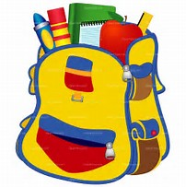 | 16
17  8:30 a.m.-Bible Study & Sunday School  10AM-Divine Service w/ LS  11AM-Fellowship Hr | 18 | 19  9AM-Quilting Group  9AM-Board & Committee Meetings  10AM-Church Council | 20  9:30 a.m.-Bible Study | 21  Articles Due for October Newsletter | 22Autumn Begins | 23
24 Quilt Dedication  8:30 a.m.-Bible Study & Sunday School  10AM-Divine Service w/ LS  11AM-Fellowship Hr | 25 | 26  Printing October Newsletter | 27  9:30 a.m.-Bible Study | 28 | 29 | 30
Vision Statement: “Share the GOSPEL”

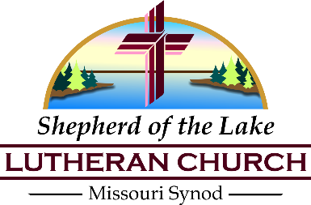
P.O. Box 155
10583 US Highway 169
Garrison, MN 56450

To Those Loved by Christ:

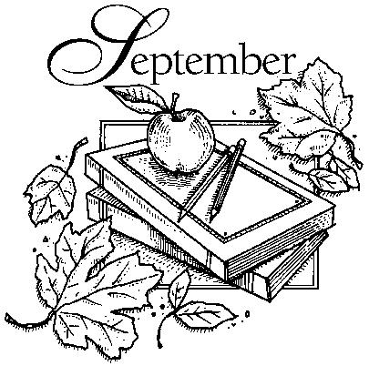
2017

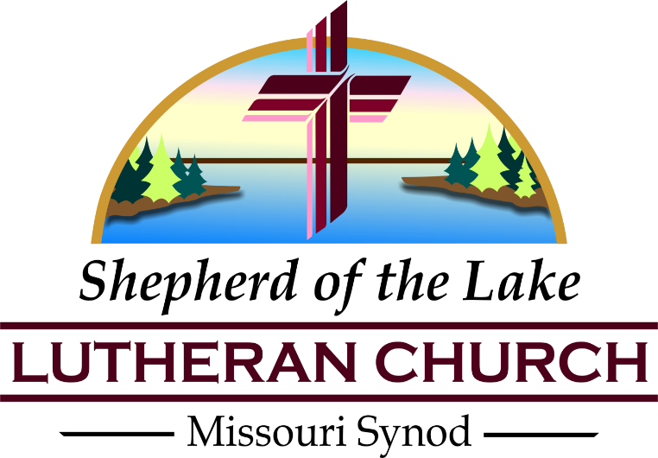
Email Addresses:
Pastor’s email: sotlpastortom@gmail.com
Secretary’s e-mail: SOTL1982@gmail.com

Phone Numbers:
Church’s #: 320-692-4581
Pastor’s Cell #: 608-334-5718

WORSHIP SCHEDULE
Sunday Education Hour: 8:30 a.m.
Sunday Divine Service: 10:00 a.m.
Fellowship Hour: 11:00 a.m.

