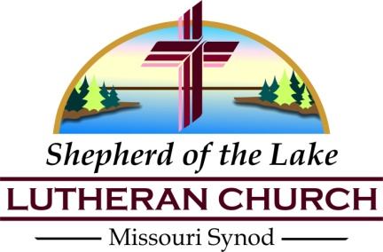
Shepherd of the Lake Lutheran Church
History of the Ministry
1979-2019

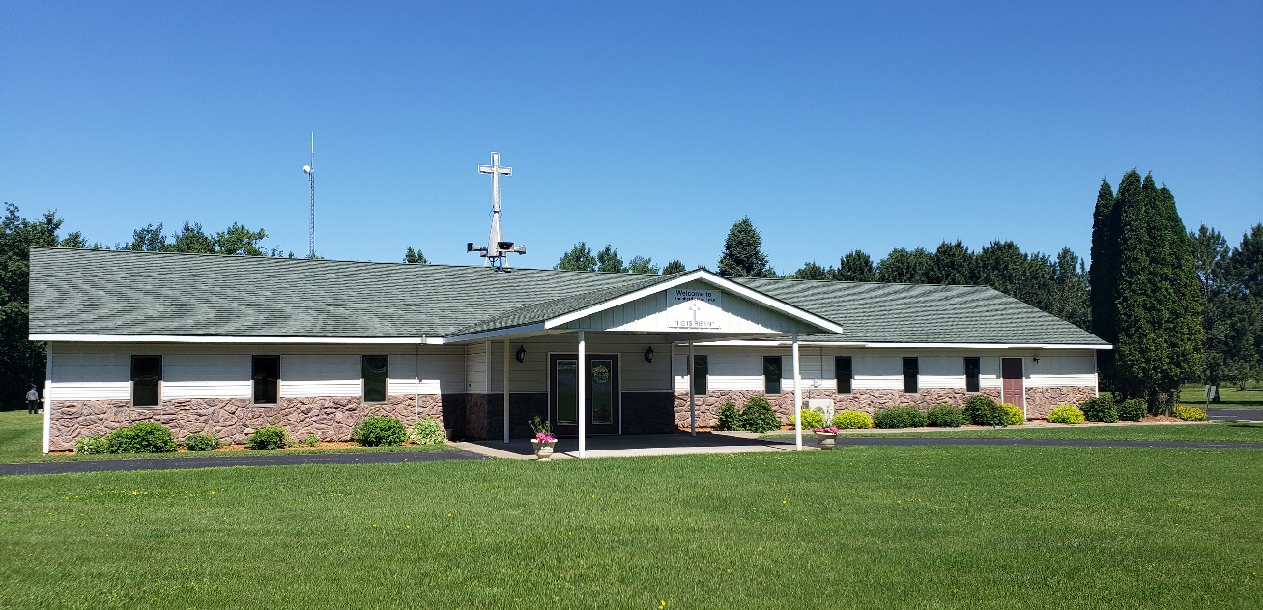

40th Anniversary

“Lord, You have been our dwelling place in all generations”
(Psalm 90:1)

Welcome, Welcome
We are so pleased that you have chosen to be a part of the 40th anniversary celebration of the Shepherd of the Lake ministry. We have followed the Shepherd for 40 years and will do so forever. As we go into the future, we will continue to follow His words and instructions for ministry.
We invite those of you visiting us today to join us for other activities in our church in the future. Please enjoy the day the Lord has given to us today and continue to promote God’s word in today’s world of confusion. Share God’s word and will with others.
God will always show us the way.

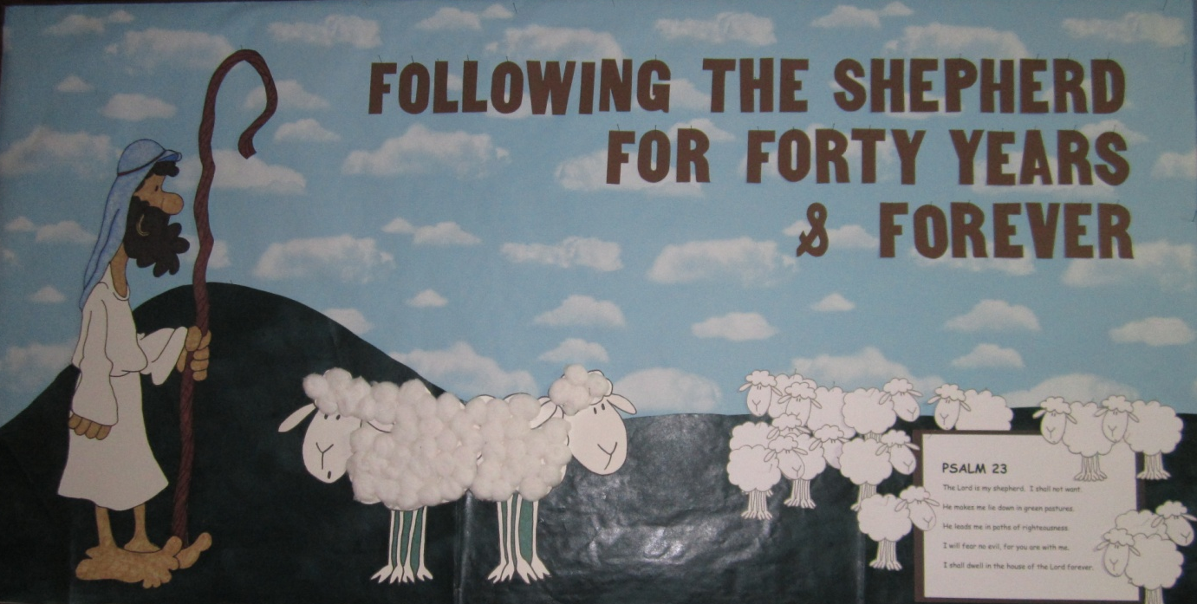

Shepherd of the Lake Lutheran Church
A Brief History

May 27, 1979 Called by the Holy Spirit, fifteen people gathered for worship in the Garrison Firehouse under Rev. Emanuel Blomquist as St. John’s Mission, Garrison

1979-1980 Vicar David Schoessow joined Pastor Blomquist.

1980-1981 Vicar David Bray joined Pastor Blomquist.

Nov. 20, 1980 St. John’s Mission, Garrison received fifty-three members, seventeen transferring from St. John’s Lutheran Church in Aitkin, MN.

1980 Joe Hall, Wyman Johnson, Carl Johnson, Ted Johnson, Carl Tonn, Norman Rynard, Bernard Kreger, Beatrice Welliver, and June Kobs formed the Mission Committee commissioned to direct future plans.

1981 Norm Rynard (Chairman), Carl Johnson, Lowell Guetzkow (Planner), and Carl Tonn formed the Building Committee. Plans were approved September 9, 1981 with the goal of raising $35,000 by the spring of 1982.

1981 A generous gift of $10,000 was given by Marie Berndt for construction of the church building.

1981 The Ladies Aid Auxiliary of John’s was formed. The first officers were: Rowena Peterson (President), June Kobs (Vice-President), Lorene Swenson (Secretary), and Beatrice Welliver (Treasurer).

1981 Site preparation began in the fall through the generosity of Elwood and Marvel Engel who provided equipment.

1981-1982 Vicar Karl Anderson came to serve St. John’s Mission, Garrison.

1982 Construction began in the spring.

1982-1983 Vicar Michael Ramey came to serve St. John’s Mission, Garrison.

July 14, 1982 Members met and chose Shepherd of the Lake Lutheran Church to be the name of the congregation formerly known as St. John’s Mission, Garrison.

Aug. 24, 1982 Shepherd of the Lake Lutheran Church officially joined the Lutheran Church – Missouri Synod. First officers: Carl Johnson (President); Ben Kreger (Vice-President); Norm Rynard (Treasurer & Financial Secretary); Linda Urevig (Secretary); Dana Harris, Howard Frick, and Carl Tonn (Trustees); John Pitcher, Leonard Urevig, and Jerry Urevig (Elders).

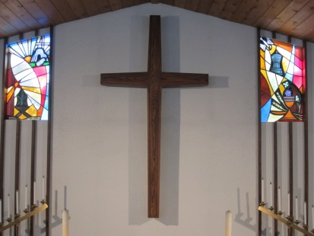
Oct. 10, 1982 A new building was dedicated to the glory of God for the worship of God in prayer and praise, the preaching of the Gospel, and the administration of the Sacraments.

1983-1984 Vicar Lawrence Richmond came to serve Shepherd of the Lake.

May 1, 1983 The Ladies Aid was officially accepted as a Society of the Lutheran Women’s Missionary League.

1984-1985 Vicar Tom Wendt came to serve as the last vicar of Shepherd of the Lake Lutheran Church.
1984 The congregation purchased the parsonage.

1985 In October, the congregation extended a Call to Rev. Terry Grzybowski who was serving in Brinkley, Arkansas. Pastor Terry accepted that Call and arrived in Garrison on November 1st with wife Nancy and children Timothy and Lindsey. He was installed on November 3rd. In 1987 Pastor and Nancy welcomed twin daughters, Julie and Jennifer, and in 1992, their son, Jordan was born.

1987-1988 The first copier was purchased and the newsletter began. A piano was purchased and a choir was formed. Wednesday morning Bible Breakfast, Sunday School, Vacation Bible School, and Youth Groups began.

1989-1990 The Church Office was enlarged and a Library/Conference Room was added.

1990 The Men’s Club was organized and sponsored many events: Ice Cream Social, Hunter’s Spaghetti Dinner, Smelt Fry, Easter Breakfast, Brat Sale, and the Annual Fall Bazaar.

1992 The garage was built with the help of the Men’s Club.

1993 Allen and Marverine Johnson generously donated a Carillon.

May 8, 1994 Organist Tiffany Peysar (now Gustin) accompanied a Festival of Hymns and Scripture to dedicate a new organ to the Lord.

May 29, 1994 Shepherd of the Lake celebrated its Fifteenth Anniversary.

1994 In the spring of 1994 Pastor Grzybowski received and accepted a Call to serve at St. Paul’s Lutheran Church in Perham, Minnesota after serving at Shepherd of the Lake for eight and a half years. During the vacancy, the Minnesota North District provided visiting pastors.

October, 1994 Shepherd of the Lake extended a Call to Reverend Paul Bartz of Richfield, Minnesota. Pastor Bartz accepted the Call and was installed on November 17, 1994 as the second full-time pastor of Shepherd of the Lake. In 1996, Pastor and his wife Bonnie were blessed with their first child, daughter Rebekah. Pastor Bartz served Shepherd of the Lake until 1998. He entered the Church Triumphant on August 15, 2013.

1995 Member, Bea Welliver bequeathed her property to Shepherd of the Lake and proceeds from the sale of that property were used for debt retirement.

1998-2000 During the vacancy period following the departure of Pastor Bartz, the Minnesota North District provided visiting pastors: Rev. Ronald Tibbetts, Rev. Henry Koopman, and Rev. John Thomson.

March 26, 2000 Rev. Curtis Foreman was installed as the third full-time pastor of Shepherd of the Lake Lutheran Church.
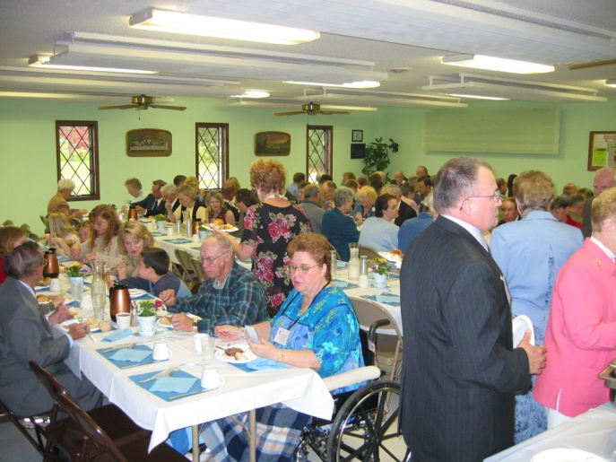
May 23, 2004

Shepherd of the Lake celebrated its Twenty-fifth Anniversary.

2004 In the Fall of 2004 Pastor Foreman retired, along with his wife Sandy, and Rev. Paul Biegner came to serve as vacancy pastor.

July 10, 2005 Rev. Matthew Ruesch was installed as the fourth full-time pastor of Shepherd of the Lake Lutheran Church after being Called as a candidate from Concordia Seminary, St. Louis, Missouri.

September 2010 Pastor Ruesch received and accepted a Call to Grace Lutheran Church and Trinity Lutheran Church, Bear Creek, Wisconsin and Rev. Walter Brill came to serve as Vacancy Pastor.

April 3, 2011 Rev. Jonathan Rusnak was ordained and installed as the fifth full-time pastor of Shepherd of the Lake Lutheran Church after being Called as a candidate from Concordia Seminary. He came with his wife Julie and son Luke, and their family grew larger while here with Evangeline and James.

2011 – 2014 A Redecorating Committee began work on the building: painting, removal of the paneling in the sanctuary, removal of the sound barriers in the fellowship hall, removal of the wall that divided the fellowship hall and the hallway, and new lighting in the sanctuary and hallway. A campaign is currently underway to fund new carpeting throughout the building.

Our annual events have continued: Smelt fry, Vacation Bible School, the Church Picnic, and the Fall Bazaar. The congregation began exploring the possibility of a senior living facility on our property in partnership with Good Shepherd Community in Sauk Rapids, Minnesota.

May 18, 2014 Shepherd of the Lake celebrated its Thirty-fifth Anniversary. Today, as we celebrate the goodness and faithfulness of God throughout these thirty-five years, we also acknowledge everyone who has served the Lord and His Church here in this place. As the current congregation, we are grateful and very appreciative of the hard work and dedication of those who have gone before us, no matter how large or small their part may be. We look forward to the Lord’s blessings in the future!

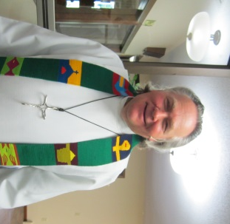
2016 Pastor Jon Rusnak accepted a call to the South Wisconsin district, to Pilgrim in Wauwatosa and moved in April. Pastor Thomas Petersen came to serve as vacancy pastor, beginning in June. Pastor Petersen was called and accepted the Call to serve SOTL in October. He was installed as pastor in December.

2017 The parking lot was resurfaced and striped. Parsonage updates were made.
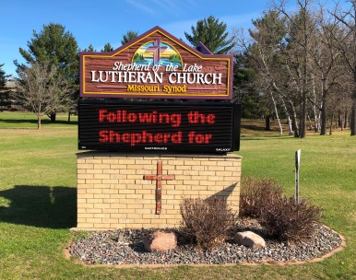
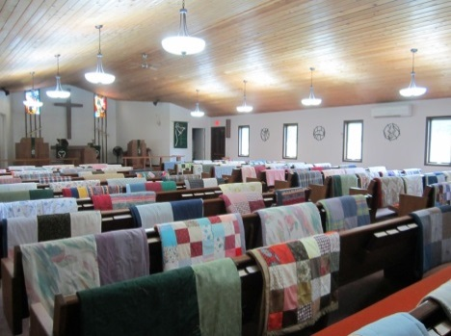
2018 A church wide photo directory was completed with the Lifetouch company. The highway sign was updated by Jerry Scherfenberg; and a new electronic sign was purchased from Indigo Sign Works, and installed in September. Outside swing-set was purchased and set up. A new combination Advent wreath and candle stand was constructed and dedicated. A wood cabinet for storage of robes and stoles was constructed for the pastor’s office. Updates were made in the hallway and bathroom. The evangelism board and members continued the Thanksgiving Dinner for the Community. A Knitting & Crochet ministry, “Busy Hands for Love” was created. Quilters sent record number of 214 Quilts to LWR. Parsonage updates were made. Pastor Petersen celebrated his 35th year as an ordained pastor.

2019 The antenna tower behind the shed was removed. Wood flower stands were constructed and dedicated in April. Ceiling lighting throughout the building is being converted to LED. Parsonage updates were made. The 40th Anniversary was celebrated on May 19, and the theme is “Following the Shepherd for Forty Years and Forever.” (Ps. 23).

We Honor Our Charter Members
We give thanks to these charter members and for the guidance of the Holy Spirit to bring us to that glorious day of the dedication of Shepherd of the Lake Lutheran Church. Much love, labor, talent, and treasure was put into this new House of Worship working together for the greater Glory of God.

*Arvin Aeshliman Angie Harris *Duane Posner
*Carole Aeshliman Troy Harris Geraldine Posner
Ivan Burandt *Carl Johnson Laura Posner
*Jack Bartishofski Edna Johnson *Norman Rynard
*Marie Bartishofski *Wyman Johnson *Harley Swenson
*Edward Baitz *Louise Johnson Lorene Swenson
*Phyllis Baitz *Mary Kulseth Allan Speck
Lee Bouley *Bernard Kreger Debbie Speck
Wendy Bouley Beulah Kreger Jessica Speck
Katie Bouley Lorna Kreger Lorraine Stenback
Brandon Bouley *Harry Kobs *Tamara Sanders
*Jeanette Brink *June Kobs Cheri Lynn Sanders
*William Dodds Candice Larson *Loren Smith
*Minnie Dodds Brock Larson *Phoebe Smith
*Howard Frick Carl Larson *Thema Tigue
*Nell Frick Beth Lawrence *Carl Tonn
David Frick Lynn Ann Lawrence *Muriel Tonn
*Starr Florek-Christie Randy LeeJoice *Leonard Urevig
Deon Florek Lynn LeeJoice Mable Urevig
Zane Florek Robbie LeeJoice Jerry Urevig
*Al Gottschalk *Otto Mueller Linda Urevig
Bessie Gottschalk *Irene Mueller Brian Urevig
Vivian Gottschalk *George Opitz Kelly Urevig
Marlan Gottschalk *Ida Opitz Mindy Urevig
*Lowell Guetzkow *Theodore Peterson Jason Urevig
*Phyllis Guetzkow *Rowena Peterson *Clarence Winterfeldt
*Dana Harris *John Pitcher *Beatrice Welliver
Virginia Harris *Betty Pitcher

Those with an *asterisk followed by their name have moved on to Church Triumphant.
We shall always remember their contributions to this congregation.

Pastors Who Served
Reverend Emanuel Blomquist 1979-1985
Reverend Terry Grzybowski 1985-1994
Reverend Paul Bartz 1994-1998
Reverend Curtis Foreman 2000-2004
Reverend Matthew Ruesch 2005-2010
Reverend Jonathan Rusnak 2011-2016
Reverend Tom Petersen 2016-

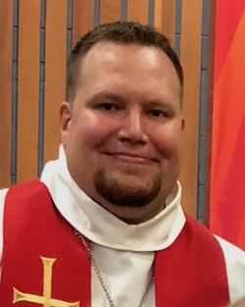
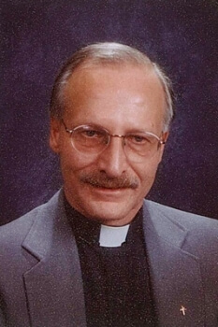
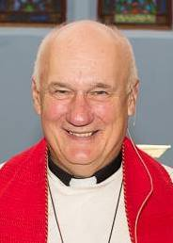

Vicars

First Vicar-David Schoessow 1979-1980
David Bray 1980-1981
Karl Anderson 1981-1982
Michael Ramey 1982-1983
Lawrence Richmond 1983-1984
Thomas Wendt 1984-1985

Vacancy Pastors

Rev. Ronald Tibbetts
Rev. Henry Koopman
Rev. John Thomson
Rev. Paul Biegner
Rev. Walter Brill

Shepherd of the Lake Lutheran Church
Congregational Officers for 2019

Church Administration Council Members:
Pastor Rev. Tom Petersen
President Arlen Kuehl
Vice-President Robert Wandersee
Recording Secretary Ken Stokes
Treasurer Linda Lennander
Financial Secretary Barb Scherfenberg
Church Secretary Susan Raddatz

Church Elders:
Chairman Gaylord Ryg
Steve Lawrence
Lee Lennander
Jerry Scherfenberg

Church Trustees:
Chairman Larry Collison
Larry Tyler
Mike Raddatz
Kurt Buhlmann

Board of Evangelism/Outreach:
Chairman Cindy Kuehl
Arlen Kuehl
Bruce Sundberg

Youth Outreach:
Steve and Beth Lawrence
Meryl Gisselquist
Jennifer Langford
Mark Langford

Board of Education:
Chairman Marie Nelson
Sheila Anderson

Ladies Aid/LWML:
President Marge Berndt
Vice-President Shari Beck
Treasurer Linda Lennander
Secretary Jo Petersen

Sunday School Teacher: Marie Nelson
Sheila Anderson

Altar Guild: Ken Stokes
Jo Petersen
Sheila Anderson
Sandy Feltmann
Marge Berndt
Barb Scherfenberg

Organists: Debbie Marlton

Worship Music: Barb Scherfenberg
Vicki Kocina
Susan Raddatz
Jessica Collison

Custodian: Bruce Sundberg

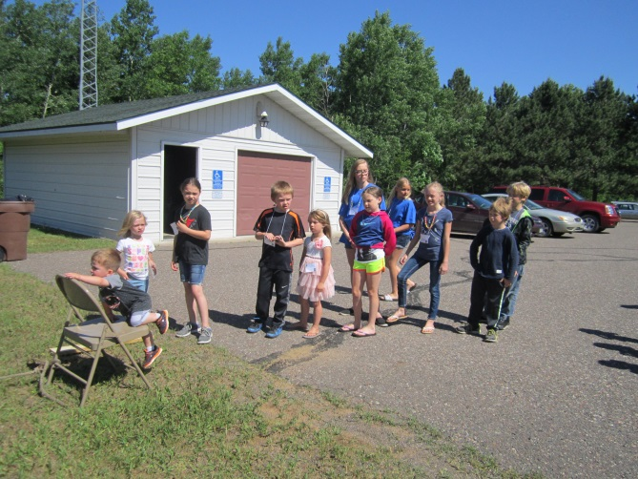
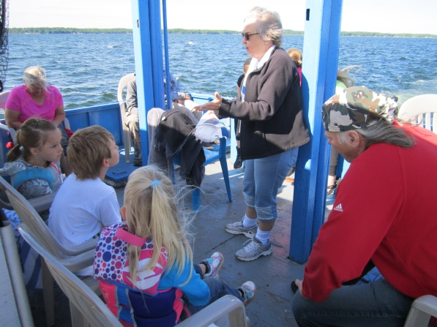
Vacation Bible School
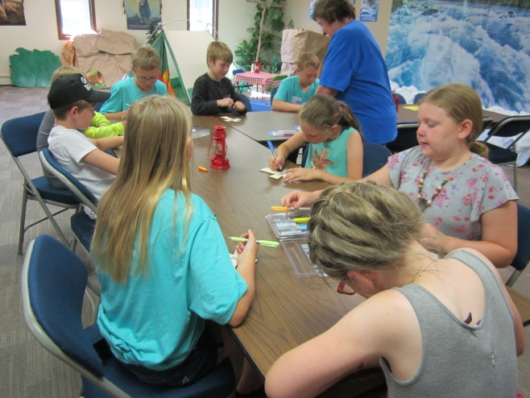

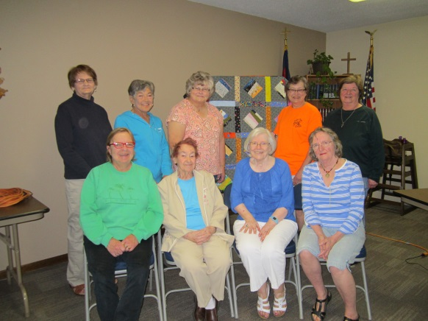
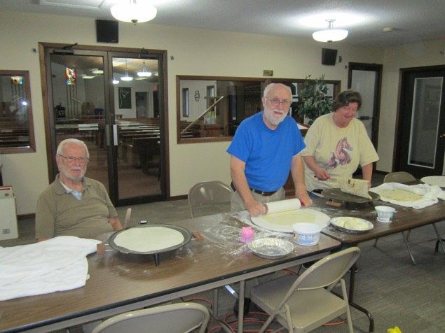

Quilters Group
Lefsa makers

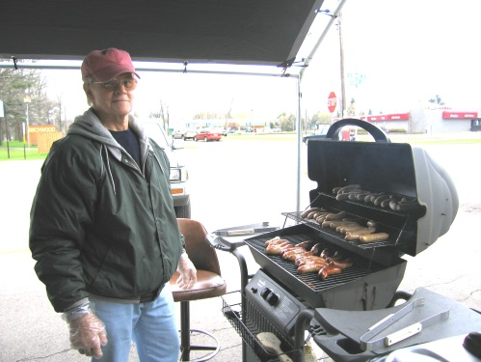
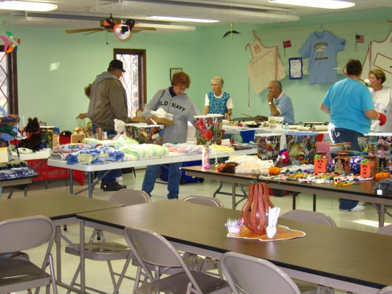
Brat Sales

Annual Bazaar

